ANNEX A: Checklist for writers and editors of documents
The checklist given in Table A. 1 is a tool to help writers and editors of documents.

Table A. 1 ̶ Checklist for writers and editors of documents
Element | Verification | Checked  ☒ | Comment
Structure | Check table of contents:  - Is the top-level structure logical?  - Is the subdivision consistent? | ☐
 | Hanging paragraphs:  - Check for and remove any hanging paragraphs. See CEN IR Part 3:2022, 22.3.3. | ☐
Use of plain language | Is the text clear and concise? | ☐
 | Are the sentences short? (check punctuation). | ☐
Language | Oxford English (British spelling in combination with the suffix -ize (rather than -ise)) shall be used throughout the document.  In case of uncertainty, refer to the Oxford English Dictionary for guidance (online version: www.oxfordlearnersdictionaries.com). | ☐
 | Maintain consistent spelling throughout the document. | ☐
Title | To be organized going from the more general to the more particular: composed of separate elements (an introductory element („Aerospace series“-mandatory), a main element (mandatory), a complementary element) each as short as possible. No more than three elements shall be used. Each element starting with a capital letter.  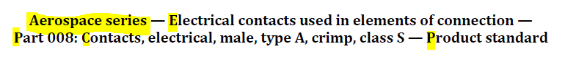 | ☐
 | Title in French: Before any double punctuation (e.g. colon) a non-breaking space is required, see below extract from standard title. E.g. Partie 004 :  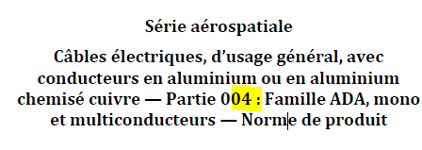 | ☐
 | The title does not unintentionally limit the scope of the document. | ☐
 | Title in three languages correct and existing. | ☐
 | Is it as clear and concise as possible? | ☐
 | If there are several parts, are the main titles aligned? | ☐
 | Use singular: e.g. „Technical Specification“. | ☐
Foreword | If the document is a revision, insert a revision statement including any amendments and technical corrigenda and a list of main technical changes with respect to previous edition. | ☐
 | Mention any other organizations involved in the drafting. | ☐
Introduction | Shall be purely informative, shall describe the content or give information on why the document is necessary. | ☐
 | Where patent rights have been identified during the preparation of the document, they shall be included in the Introduction. | ☐
Scope | Scope shall describe what the document does, state where it is applicable and only contain statements of fact. | ☐
 | Forms of expression such as the following shall be used:  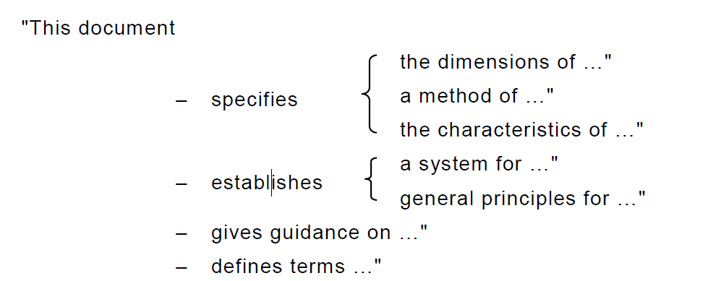 | ☐
 | Statements of applicability of the document shall be introduced by wording such as:  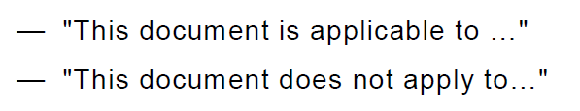 | ☐
Normative references | The Normative reference clause (Clause 2) is a mandatory element, even if it contains no normative references. In case of no normative references, verify the presence of a statement: “There are no normative references in this document”. | ☐
 | Are all of the references listed in the Normative references clause cited in the text in such a way that some or all of their content constitutes requirements of the document? | ☐
 | Are the references dated or undated? | ☐
 | Are the normative references publicly available? | ☐
 | The source shall be mentioned if standard is not EN or ISO. | ☐
 | The EN number shall be written as „EN 1234“ using a non-breaking space „strg+shift+space“ between EN and Number. | ☐
 | The standard title in Normative references shall be written in italic. | ☐
 | Referencing can be done to EN if at least ASD-STAN prEN has already been published with the footnote: See Annex D | ☐
Terms and Definitions | All the terms listed shall be used in the document. | ☐
 | The Terms and definitions clause (Clause 3) is a mandatory element, even if it contains no terminological entries. In case of no terms and definitions, verify the presence of a statement: “No terms and definitions are listed in this document.” | ☐
 | Are the definitions correctly drafted? | ☐
 | Terms shall be written in lowercase letters. | ☐ | Uppercase letters, mathematical symbols, typographical signs, and syntactic signs as well as their character styles shall be used in a term only if they constitute part of the normal written form of the term.
 | Terms shall in general be presented in their basic grammatical form (nouns in the singular, verbs in the infinitive). | ☐
 | The definition shall be written in such a form that it can replace the term in its context. It shall not start with an article („the“, „a“) nor end with a full stop. | ☐
 | A definition shall not take the form of, or contain, a requirement. | ☐
 | Do suitable terms exist in the terminology databases? https://www.electropedia.org/  https://www.iso.org/obp | ☐
 | Footnotes to any part of a terminological entry are not allowed. To provide supplementary information use „Note # to entry:“. To provide the information that illustrates the concept use „EXAMPLE“. | ☐
 | Notes to a terminological entry shall be sequentially numbered starting with "1" within each terminological entry. | ☐
 | "EXAMPLE" shall be numbered starting with "1" within each terminological entry. A single example in a terminological entry shall not be numbered. | ☐
Figures | Does each figure have a concise title? | ☐
 | Is each figure numbered correctly? By default, figures are numbered with Arabic numerals, beginning with 1, and the numbering shall be continuous and independent of the numbering of the clauses and of any tables. In annexes, the figure numbering restarts, and the number is preceded by the annex letter (e.g. Figure A.1, Figure A.2, …). | ☐
 | Is there a key if necessary? | ☐
 | Are all figures cross-referenced in the text? | ☐
 | Figures shall be of a good quality and be language neutral in order to facilitate translation, using key references or figure footnotes instead of textual descriptions. | ☐
Tables | Does each table have a concise title? | ☐
 | Is each table numbered correctly? Table numbering: Tables shall be designated “Table” and numbered. By default, tables are numbered with Arabic numerals, beginning with 1, and the numbering shall be continuous and independent of the numbering of the clauses and of any figures. A single table shall be designated "Table 1". | ☐
 | Are all tables cross-referenced in the text? | ☐
 | When a table is continued over several pages, the column headings should be repeated on all pages after the first. | ☐ | use the Word option “Repeat header row”
 | Further table subdivision [e.g. Table 1a)] is not permitted. A table within a table is not permitted. | ☐
 | A Figure within in a Table is not permitted. | ☐
 | Column Headlines shall be bold. | ☐
 | Borderlines: Outer borderlines shall be 1,5 pt and inner lines shall be 0,75 pt. | ☐
 | Values (Columns) shall have units. | ☐
 | Repeat values if they apply to multiple entries. No empty cells, shapes (e.g. arrows) are permmitted in the table. Use em dash (—) if no value applies. | ☐
 | For specific forms and templates which are formatted as tables, empty cells are allowed for editorial purposes (see clause 6.5). | ☐
 | Ensure consistent row structure in tables to maintain horizontal readability in XML. Do not use tab characters or enters for alignment but instead use invisible cell division borders.  E.g.  Column 1 Column 2 Column 3  Unit 2 Unit 3  Data Data Data  Subdata 1 - WYZ  - Subdata 2 ZYX  When text lines have different heights due to tabs and enters, columns may not have equal heights. For example, if "Subdata 2" has a raised footnote or spans two lines while "ZYX" does not, "ZYX" won't be at the same height as "Subdata 2" in the column. | ☐
 | Avoid nested tables (see clause 6.6.) | ☐
Annexes | Is there a reference to each annex in the main part of the text? | ☐
 | Is their status (normative or informative) correct? Is this made clear in the main part of the text? | ☐
Bibliography | Is it formatted consistently? | ☐
 | Are all the entries correct and complete? | ☐
 | Are any of them normative references that should be listed in Clause 2? | ☐
 | Are any of the listed documents duplicated in Clause 2 “Normative references”? | ☐
Drafting of provisions | Use "shall" for requirements instead of "must". Use “should" for recommendations, use “may” for permissions and “can” to express possibilities see Sub-clause 6.1 | ☐
 | Make sure that "shall", "should" or "may" are not used in the Foreword, Scope, notes or examples. | ☐
 | Make sure that "shall", is not used in the Introduction. | ☐
 | Are "may" and "can" used correctly?  - “May” to be used to express permissions.  - “Can” to be used to express possibilities. | ☐
 | Is "must" used anywhere in the document? Is "must" used correctly to mean external constraints? | ☐
Potential legal problems | Copyrights. No texts shall be copied from external organizations (and/or other SDOs) without prior written consent. | ☐
 | Trademarks: Proprietary trade names or trademarks for a particular product should as far as possible be avoided, even if they are in common use.  If, exceptionally, trade names or trademarks cannot be avoided, their nature shall be indicated, for example by the symbol ® for a registered trademark and by the symbol TM for a trademark.  The trade name or trademark of the product may be given in the text of the document but shall be associated with a footnote as shown below.  „… [trade name or trademark of product] … is the [trade name or trademark] of a product supplied by … [supplier] …. This information is given for the convenience of users of this document and does not constitute an endorsement by … [ISO or IEC] … of the product named. Equivalent products may be used if they can be shown to lead to the same results“. | ☐
 | No requirements specifying compliance with national/legal regulations are permitted. If there is any technical requirement it shall be described, but it cannot be a direct reference to the legislation. If necessary, a note with a factual reference to the legislation may be included, but there should be a separation between one and the other (e.g. in line with REACH) | ☐
Conformity assessment | Are there potential conformity assessment issues? | ☐
Cross-references | Are all cross-references correct? | ☐
Common problems | Are symbols for variable quantities correct, consistent and properly formatted in the text and in mathematical formulae? | ☐
Supersession information | If the document is a revision, the document shall mention that it is replacing an existing deliverable. | ☐
Designation | The designation shall not exceed 15 characters. | ☐ | IT System limitation
 | Designations shall be written according to Clause 8. | ☐
Marking | If needed „Marking“ shall be in accordance with EN 2424. | ☐
 | If needed the marking position shall be shown in a figure or as per manufacturers option. | ☐
Quality Management System | Option 1:  Product Standard: "The manufacturer’s operations shall be an approved production organization for aerospace products and shall demonstrate that it has implemented and is able to maintain a quality management system according to aerospace accepted and established quality management system)."  Specification: "The qualification procedure for aerospace standard products according to an aerospace accepted and established qualification procedure shall be used and documented according to the specified tests if not otherwise agreed between customer and supplier."  Option 2:  Product Standard: "The manufacturer’s operations shall be an approved production organization for aerospace products and shall demonstrate that it has implemented and is able to maintain a quality management system (e.g. according to EN 9100 or an equivalent aerospace accepted and established quality management system)."  Specification: "The qualification procedure for aerospace standard products (e.g. according to EN 9133 or an equivalent aerospace accepted and established qualification procedure) shall be used and documented according to the specified tests if not otherwise agreed between customer and supplier." | ☐
Specific writing  General Check/Other issues | The decimal sign shall be a comma on the line in all language versions (preceded by a zero if number is less than 1). [see CEN-CENELEC Internal regulations part 3, 9.1] | ☐
 | Indices: Cambria, non-Italic. | ☐
 | Units: Cambria. | ☐
 | Symbols/Variables in: Cambria, Italic. | ☐
 | Product standard: General tolerance shall be included (as far as applicable) E.g. ISO 1132-1. | ☐
 | Temperature range should be written without a Plus expression in the positive temperature range, only minus is shown. | ☐ | e.g.: "temperature range: −55 °C to 150 °C"
 | File name: Ensure correct Document type, Standard number, Status (NWP, CTD, CD, FVrev.), Date. | ☐ | E.g.:  prEN_1234_P4_CTD_2024-02-23.docx  FprEN_1234_P4_FVrev_2024-02-23.docx
 | Have previous comments (NWP, NDB/ENQ, FV) been disposed and agreed comments implemented? | ☐

